**TAG Z - Lane Cove LEP 2009 Amend No 8 – Pacific Highway/ Longueville Rd precinct**

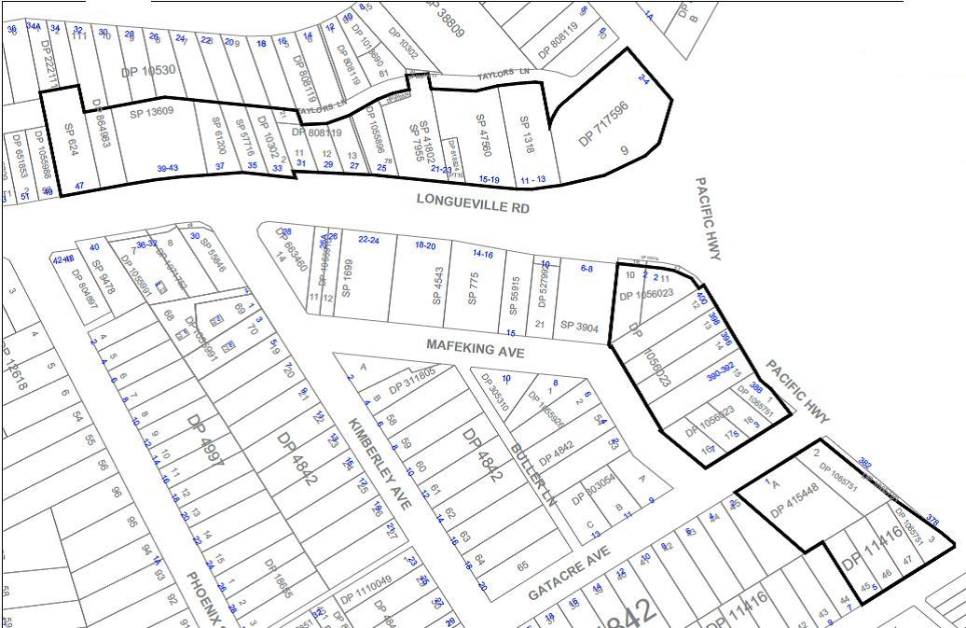

Increase height from 12m to 18m except Lot 9 DP717596 HOB of 25m

**Northern block**

**Central block**

**Southern block**

Decrease FSR from 4.1:1 to 2.4:1 across all sites

Increase height from 12m to 15m

**Fig 1**

Entire area covered by Amend No 8

Increase height from 12m to 25m